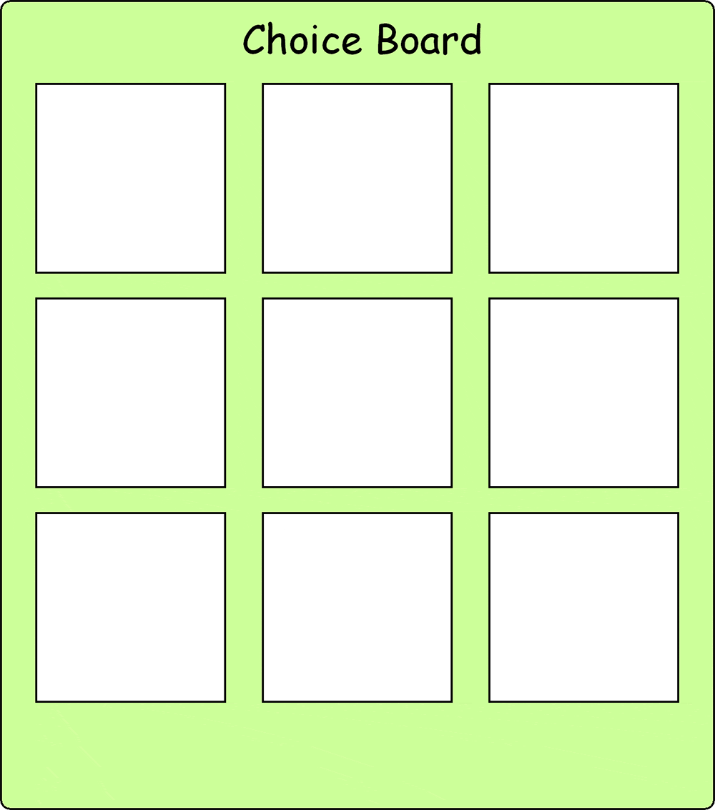

Source: http://visuals.autism.net/main.php?g2_itemId=103

